# Introduction to desktop flows

Desktop flows broaden the existing robotic process automation (RPA) capabilities in Power Automate and enable you to automate all repetitive desktop processes. Automating is quicker and easier than ever with the new intuitive Power Automate desktop flow designer using the prebuilt drag-and-drop actions or recording your own desktop flows to run later.

Desktop flows are addressed to essentially everyone who is performing simple or complex rule-based tasks on their workstations. Users at home, small businesses, enterprises, or larger companies can leverage automation capabilities in Power Automate to create flows, interact with everyday tools like email and Excel, or work with modern and legacy applications. Examples of simple and complex tasks you can automate are:

* Quickly organize your documents using dedicated files and folders actions
* Accurately extract data from websites and store them in Excel files using web and Excel automation
* Apply desktop automation capabilities to put your work on autopilot

If you're a home user who is accessing a weather website to see tomorrow's forecast or a self-employed businessperson extracting information from vendors' invoices or even an employee of a large enterprise who automates data entry on an ERP system, Power Automate is designed for you.

It allows you to automate both legacy applications, such as terminal emulators, modern web and desktop applications, Excel files, and folders. You can interact with the machine using application UI elements, images, or coordinates.

Sign in to Power Automate Windows application using one of the following accounts and automate your tedious tasks:

* [Getting started with a Microsoft account](https://learn.microsoft.com/en-us/power-automate/desktop-flows/getting-started-msa)
* [Getting started with a work or school account](https://learn.microsoft.com/en-us/power-automate/desktop-flows/getting-started-freeorg)
* [Getting started with an Organization premium account](https://learn.microsoft.com/en-us/power-automate/desktop-flows/getting-started-org)

A full comparison of the features included in each account can be found at [Sign-in account comparison](https://learn.microsoft.com/en-us/power-automate/desktop-flows/setup#sign-in-account-comparison).

Here's a list of [Known issues and limitations](https://learn.microsoft.com/en-us/power-automate/desktop-flows/setup#known-issues-and-limitations) for Power Automate.

To create desktop flows using legacy Windows recorder (V1) and Selenium IDE as alternative solutions, go to [Introduction to other types of desktop flows](https://learn.microsoft.com/en-us/power-automate/desktop-flows/overview).

# Get started with Power Automate in Windows 11

Windows 11 allow users to create automations through the preinstalled Power Automate app. Power Automate is a low-code platform that enables home and business users to optimize their workflows and automate repetitive and time-consuming tasks.

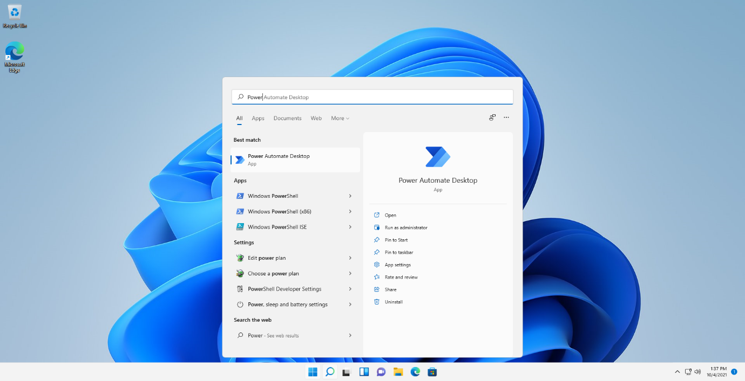

Any Windows user can build flows with little-to-no coding experience. A collection of more than 400 premade actions and a recorder that captures mouse and keyboard functions make robotic process automation (RPA) intuitive for both regular and power users.

Using the available actions, you can automate virtually any Microsoft and third-party application on Windows and exchange data between different applications and webpages.

For example, you can extract prices from shopping websites, compare them, and store them to Excel spreadsheets by deploying some easy-to-configure actions.

Using Power Automate, you can populate any form and reduce the time needed to enter data on regularly used applications. Performing repetitive online orders, tracking price changes, populating fields on web pages and desktop applications, creating backups, and converting files are all tasks that can be fully automated with desktop flows.

Apart from the premade actions, Power Automate enables you to record your activity and automatically convert these steps into actions. The recording feature makes RPA friendly to all non-technical users and allows you to develop simple flows effortlessly.

To start your journey with desktop flows, follow our [getting started guide](https://learn.microsoft.com/en-us/power-automate/desktop-flows/getting-started-msa). More technical starting guides are available for users with a [work or school account](https://learn.microsoft.com/en-us/power-automate/desktop-flows/getting-started-freeorg) and [organization premium account](https://learn.microsoft.com/en-us/power-automate/desktop-flows/getting-started-org). Check the [Sign-in account comparison](https://learn.microsoft.com/en-us/power-automate/desktop-flows/setup#sign-in-account-comparison) to view what each version offers.

# Power Automate for desktop architecture

**In this article**

1. [Attended/Unattended desktop direct connectivity to the cloud service](https://learn.microsoft.com/en-us/power-automate/desktop-flows/pad-architecture#attendedunattended-desktop-direct-connectivity-to-the-cloud-service)
2. [Attended/Unattended desktop connectivity to the cloud service using the on-premises data gateway](https://learn.microsoft.com/en-us/power-automate/desktop-flows/pad-architecture#attendedunattended-desktop-connectivity-to-the-cloud-service-using-the-on-premises-data-gateway)
3. [Other Power Automate outgoing web requests](https://learn.microsoft.com/en-us/power-automate/desktop-flows/pad-architecture#other-power-automate-outgoing-web-requests)
4. [Session credential lifecycle](https://learn.microsoft.com/en-us/power-automate/desktop-flows/pad-architecture#session-credential-lifecycle)

**Important**

* Selenium IDE is deprecated and will no longer work after February 28th, 2023. Migrate your flows to Power Automate for desktop or delete them.
* Gateways for desktop flows are no longer supported. Switch to our machine-management capabilities. Learn more about [**switching from gateways to direct connectivity**](https://learn.microsoft.com/en-us/power-automate/desktop-flows/manage-machines#switch-from-gateways-to-direct-connectivity).

There are two different methods that Power Automate can use to connect to the cloud services in order to receive flow execution jobs. The first option is direct connectivity, while the second option requires the on-premises data gateway to be installed.

The data flow between the desktop and the cloud is the same in both options; only the application and user account that initiates the web requests are different.

**Attended/Unattended desktop direct connectivity to the cloud service**

The **UIFlowService** is a Windows service that is installed with Power Automate on the desktop machine. By default, it's set to start automatically and runs as the new user **NT SERVICE\UIFlowService**. This user is created during installation.

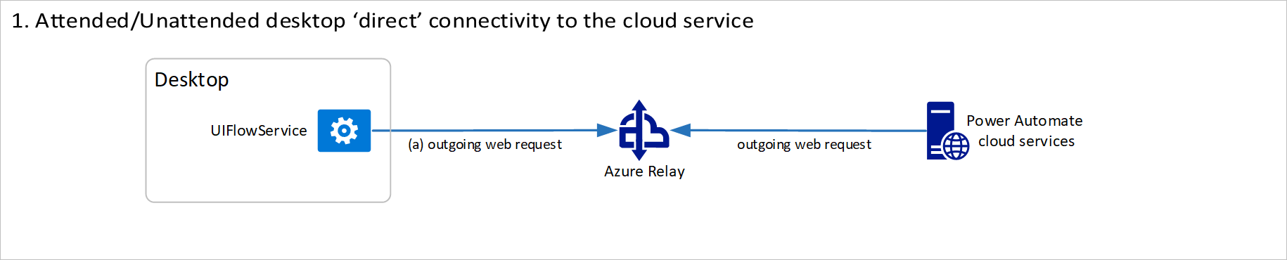

Azure Relay is a service that facilitates communication channels that are established entirely by making outgoing requests to the service. It achieves this functionality either by establishing a WebSocket connection or using HTTP long-polling, if necessary.

**Note**

The Azure Relay and Power Automate cloud services are both cloud resources in Azure. You can find more information about Azure Relay in [**What is Azure Relay**](https://learn.microsoft.com/en-us/azure/azure-relay/relay-what-is-it).

The outgoing web requests from the **UIFlowService** on the desktop machine to Azure Relay in the cloud use HTTPS to make requests to FQDN **\*.servicebus.windows.net** over port 443.

Destination IP addresses for Azure Relay can be found at [Azure IP Ranges and Service Tags](https://www.microsoft.com/download/details.aspx?id=56519) for the public cloud under the name **ServiceBus**. Similar documents are available for the other Azure national clouds. No inbound ports are required to be open on the desktop machine.

**Attended/Unattended desktop connectivity to the cloud service using the on-premises data gateway**

**Note**

Power Automate now offers direct connectivity to the cloud without the use of on-premises data gateways. You can find more information in [**Attended/Unattended desktop direct connectivity to the cloud service**](https://learn.microsoft.com/en-us/power-automate/desktop-flows/pad-architecture#attendedunattended-desktop-direct-connectivity-to-the-cloud-service).

The **UIFlowService** is a Windows service that is installed with Power Automate on the desktop machine. The [on-premises data gateway](https://learn.microsoft.com/en-us/data-integration/gateway/service-gateway-onprem) Windows service is a separately installed component that acts as a communications gateway between the **UIFlowService** and Azure Relay.

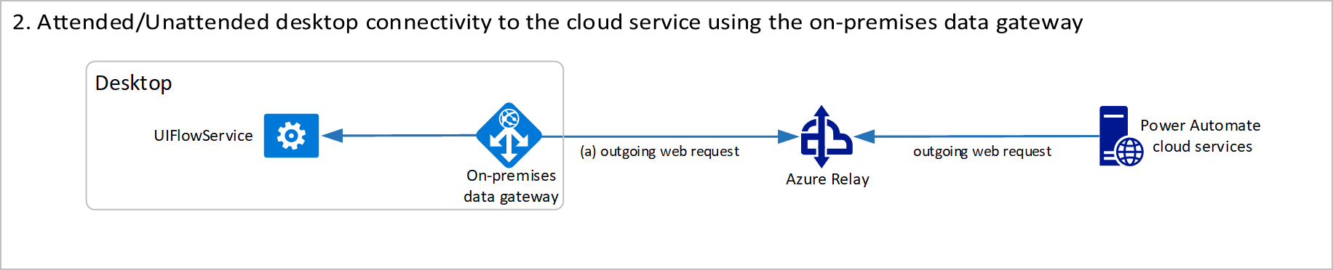

By default, the data gateway service is set to start automatically and run as the new user **NT SERVICE\PBIEgwService**. This user is created during installation.

Azure Relay is a service that facilitates communication channels that are established entirely by making outgoing requests to the service. It achieves this functionality either by establishing a WebSocket connection or using HTTP long-polling, if necessary.

**Note**

The Azure Relay and Power Automate cloud services are both cloud resources in Azure. You can find more information about Azure Relay in [**What is Azure Relay**](https://learn.microsoft.com/en-us/azure/azure-relay/relay-what-is-it).

The details about this data flow are documented in [Adjust communication settings](https://learn.microsoft.com/en-us/data-integration/gateway/service-gateway-communication). The firewall requirements for execution are exactly the same as the direct connectivity option, but a different service and user account will be making the outgoing requests.

**Other Power Automate outgoing web requests**

Power Automate makes some additional outgoing web requests at runtime, which are documented in [Desktop flows services required for runtime](https://learn.microsoft.com/en-us/power-automate/ip-address-configuration#desktop-flows-services-required-for-runtime).

The CRL endpoints are only required if you use the on-premises data gateway. They use HTTP over port 80 and are initiated by the **UIFlowService**.

The WebDriver endpoints are only required if you use Selenium IDE desktop flows and have an automatically updating browser. These endpoints use HTTPS over port 443 and are initiated by the **Microsoft.Flow.RPA.Agent.exe** process using the user account that is running the desktop flow.

**Session credential lifecycle**

1. A desktop machine is registered by signing in to the on-premises data gateway or registering inside Power Automate using the direct connectivity feature. This process generates a public and private key to be used for secure communication with this machine.
2. The machine registration request is sent by the desktop application to the Power Automate cloud services. The request contains the newly generated machine's public key. This key is stored along with the machine registration in the cloud.
3. When the request completes, the machine is successfully registered and appears in the Power Automate web portal as a resource that can be managed. However, the machine cannot be used by a flow until a connection to it is established.
4. To establish a Power Automate connection in the web portal, users must select an available machine and provide the username and password credentials of the account to use to run the desktop flow.

Users can select any previously registered machine, including machines that have been shared with them. When a connection is saved, the credentials are encrypted using the public key associated with the machine and stored in this encrypted form.

The cloud service is storing the encrypted user credentials for the machine. However, it can't decrypt the credentials because the private key only exists on the desktop machine. The user can delete this connection at any point, and the stored encrypted credentials will also be deleted.

1. When a desktop flow is run from the cloud, it uses a previously established connection selected in the **Run a flow built with Power Automate for desktop** action.
2. When the desktop flow job is sent from the cloud to the desktop, it includes the encrypted credentials stored in the connection. These credentials are then decrypted on the desktop using the secret private key, and they're used to sign in as the given user account.

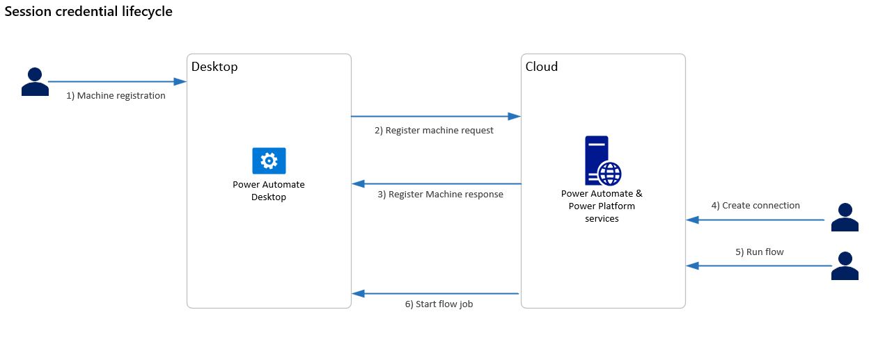

Although the logical data flow is from the cloud to the desktop, the connection is established from the desktop to the cloud. It uses Azure Relay to connect to the cloud using an outgoing web request.

If a gateway cluster is created using the on-premises data gateway, the private key used to decrypt credentials is generated on all machines in the cluster. The private key is generated using the recovery key that is requested during machine registration. The recovery key is never sent to the cloud.

If a machine group is created using direct connectivity, the group's private key is encrypted using a user-defined group password. Then, it's sent to the cloud for storage as part of the register machine request.

The encrypted private key is shared with other machines that join the group. However, as the user must first provide the password to decrypt this private key, the service can't read any stored credentials in the connection.

# Power Automate for desktop architecture

**In this article**

1. [Attended/Unattended desktop direct connectivity to the cloud service](https://learn.microsoft.com/en-us/power-automate/desktop-flows/pad-architecture#attendedunattended-desktop-direct-connectivity-to-the-cloud-service)
2. [Attended/Unattended desktop connectivity to the cloud service using the on-premises data gateway](https://learn.microsoft.com/en-us/power-automate/desktop-flows/pad-architecture#attendedunattended-desktop-connectivity-to-the-cloud-service-using-the-on-premises-data-gateway)
3. [Other Power Automate outgoing web requests](https://learn.microsoft.com/en-us/power-automate/desktop-flows/pad-architecture#other-power-automate-outgoing-web-requests)
4. [Session credential lifecycle](https://learn.microsoft.com/en-us/power-automate/desktop-flows/pad-architecture#session-credential-lifecycle)

**Important**

* Selenium IDE is deprecated and will no longer work after February 28th, 2023. Migrate your flows to Power Automate for desktop or delete them.
* Gateways for desktop flows are no longer supported. Switch to our machine-management capabilities. Learn more about [**switching from gateways to direct connectivity**](https://learn.microsoft.com/en-us/power-automate/desktop-flows/manage-machines#switch-from-gateways-to-direct-connectivity).

There are two different methods that Power Automate can use to connect to the cloud services in order to receive flow execution jobs. The first option is direct connectivity, while the second option requires the on-premises data gateway to be installed.

The data flow between the desktop and the cloud is the same in both options; only the application and user account that initiates the web requests are different.

**Attended/Unattended desktop direct connectivity to the cloud service**

The **UIFlowService** is a Windows service that is installed with Power Automate on the desktop machine. By default, it's set to start automatically and runs as the new user **NT SERVICE\UIFlowService**. This user is created during installation.



Azure Relay is a service that facilitates communication channels that are established entirely by making outgoing requests to the service. It achieves this functionality either by establishing a WebSocket connection or using HTTP long-polling, if necessary.

**Note**

The Azure Relay and Power Automate cloud services are both cloud resources in Azure. You can find more information about Azure Relay in [**What is Azure Relay**](https://learn.microsoft.com/en-us/azure/azure-relay/relay-what-is-it).

The outgoing web requests from the **UIFlowService** on the desktop machine to Azure Relay in the cloud use HTTPS to make requests to FQDN **\*.servicebus.windows.net** over port 443.

Destination IP addresses for Azure Relay can be found at [Azure IP Ranges and Service Tags](https://www.microsoft.com/download/details.aspx?id=56519) for the public cloud under the name **ServiceBus**. Similar documents are available for the other Azure national clouds. No inbound ports are required to be open on the desktop machine.

**Attended/Unattended desktop connectivity to the cloud service using the on-premises data gateway**

**Note**

Power Automate now offers direct connectivity to the cloud without the use of on-premises data gateways. You can find more information in [**Attended/Unattended desktop direct connectivity to the cloud service**](https://learn.microsoft.com/en-us/power-automate/desktop-flows/pad-architecture#attendedunattended-desktop-direct-connectivity-to-the-cloud-service).

The **UIFlowService** is a Windows service that is installed with Power Automate on the desktop machine. The [on-premises data gateway](https://learn.microsoft.com/en-us/data-integration/gateway/service-gateway-onprem) Windows service is a separately installed component that acts as a communications gateway between the **UIFlowService** and Azure Relay.



By default, the data gateway service is set to start automatically and run as the new user **NT SERVICE\PBIEgwService**. This user is created during installation.

Azure Relay is a service that facilitates communication channels that are established entirely by making outgoing requests to the service. It achieves this functionality either by establishing a WebSocket connection or using HTTP long-polling, if necessary.

**Note**

The Azure Relay and Power Automate cloud services are both cloud resources in Azure. You can find more information about Azure Relay in [**What is Azure Relay**](https://learn.microsoft.com/en-us/azure/azure-relay/relay-what-is-it).

The details about this data flow are documented in [Adjust communication settings](https://learn.microsoft.com/en-us/data-integration/gateway/service-gateway-communication). The firewall requirements for execution are exactly the same as the direct connectivity option, but a different service and user account will be making the outgoing requests.

**Other Power Automate outgoing web requests**

Power Automate makes some additional outgoing web requests at runtime, which are documented in [Desktop flows services required for runtime](https://learn.microsoft.com/en-us/power-automate/ip-address-configuration#desktop-flows-services-required-for-runtime).

The CRL endpoints are only required if you use the on-premises data gateway. They use HTTP over port 80 and are initiated by the **UIFlowService**.

The WebDriver endpoints are only required if you use Selenium IDE desktop flows and have an automatically updating browser. These endpoints use HTTPS over port 443 and are initiated by the **Microsoft.Flow.RPA.Agent.exe** process using the user account that is running the desktop flow.

**Session credential lifecycle**

1. A desktop machine is registered by signing in to the on-premises data gateway or registering inside Power Automate using the direct connectivity feature. This process generates a public and private key to be used for secure communication with this machine.
2. The machine registration request is sent by the desktop application to the Power Automate cloud services. The request contains the newly generated machine's public key. This key is stored along with the machine registration in the cloud.
3. When the request completes, the machine is successfully registered and appears in the Power Automate web portal as a resource that can be managed. However, the machine cannot be used by a flow until a connection to it is established.
4. To establish a Power Automate connection in the web portal, users must select an available machine and provide the username and password credentials of the account to use to run the desktop flow.

Users can select any previously registered machine, including machines that have been shared with them. When a connection is saved, the credentials are encrypted using the public key associated with the machine and stored in this encrypted form.

The cloud service is storing the encrypted user credentials for the machine. However, it can't decrypt the credentials because the private key only exists on the desktop machine. The user can delete this connection at any point, and the stored encrypted credentials will also be deleted.

1. When a desktop flow is run from the cloud, it uses a previously established connection selected in the **Run a flow built with Power Automate for desktop** action.
2. When the desktop flow job is sent from the cloud to the desktop, it includes the encrypted credentials stored in the connection. These credentials are then decrypted on the desktop using the secret private key, and they're used to sign in as the given user account.



Although the logical data flow is from the cloud to the desktop, the connection is established from the desktop to the cloud. It uses Azure Relay to connect to the cloud using an outgoing web request.

If a gateway cluster is created using the on-premises data gateway, the private key used to decrypt credentials is generated on all machines in the cluster. The private key is generated using the recovery key that is requested during machine registration. The recovery key is never sent to the cloud.

If a machine group is created using direct connectivity, the group's private key is encrypted using a user-defined group password. Then, it's sent to the cloud for storage as part of the register machine request.

The encrypted private key is shared with other machines that join the group. However, as the user must first provide the password to decrypt this private key, the service can't read any stored credentials in the connection.

# Premium RPA features

**In this article**

1. [Premium feature list](https://learn.microsoft.com/en-us/power-automate/desktop-flows/premium-features#premium-feature-list)
2. [Plans that provide entitlements for the premium RPA features](https://learn.microsoft.com/en-us/power-automate/desktop-flows/premium-features#plans-that-provide-entitlements-for-the-premium-rpa-features)
3. [More information about Power Automate licensing](https://learn.microsoft.com/en-us/power-automate/desktop-flows/premium-features#more-information-about-power-automate-licensing)

This article lists the premium robotic process automation (RPA) features and benefits that are included in the Power Automate Premium plan (previously Power Automate per user with attended RPA) and are available to [organization premium accounts](https://learn.microsoft.com/en-us/power-automate/desktop-flows/getting-started-org).

**Premium feature list**

| **Feature/Benefit** | **Description** | **Additional information** |
| --- | --- | --- |
| **Automatic triggering/scheduling and integration with cloud flows** | **Trigger/schedule attended or unattended desktop flow runs from cloud flows. Integrate with cloud flows and connect to hundreds of cloud apps and services.** | [**Learn how to trigger desktop flows from cloud flows**](https://learn.microsoft.com/en-us/power-automate/desktop-flows/trigger-desktop-flows) |
| **Flow triggering via desktop shortcut** | **Trigger local attended desktop flows through their desktop shortcuts.** | [**Learn how to trigger a desktop flow via shortcut**](https://learn.microsoft.com/en-us/power-automate/desktop-flows/run-desktop-flows-url-shortcuts) |
| **Flow triggering via URL** | **Trigger local attended desktop flows through their run URLs from anywhere on your machine.** | [**Learn how to trigger a desktop flow via URL**](https://learn.microsoft.com/en-us/power-automate/desktop-flows/run-desktop-flows-url-shortcuts) |
| **Access to premium and custom connectors** | **Access all premium cloud connectors and create custom connectors.** | [**Learn about premium connectors**](https://learn.microsoft.com/en-us/connectors/connector-reference/connector-reference-premium-connectors)[**Learn about custom connectors**](https://learn.microsoft.com/en-us/connectors/custom-connectors) |
| **AI Builder capacity** | **Infuse AI into your cloud flows through custom or prebuilt models with AI Builder.** | [**Learn about AI Builder**](https://learn.microsoft.com/en-us/ai-builder) |
| **Access to process mining** | **Visualize and analyze your business processes with process mining.** | [**Learn about process mining**](https://learn.microsoft.com/en-us/power-automate/process-advisor-overview) |
| **Access to cloud connectors from desktop flows** | **Use cloud connectors directly in desktop flows.** | [**Learn how to invoke the SharePoint cloud connector from desktop flows**](https://learn.microsoft.com/en-us/power-automate/desktop-flows/actions-reference/sharepoint) |
| **Custom actions** | **Ability to use custom developed automation actions in desktop flows** | [**Learn how to create and use custom actions in desktop flows**](https://learn.microsoft.com/en-us/power-automate/desktop-flows/custom-actions) |
| **Sharing and collaboration** | **Share flows between team members and select access levels such as co-owner or user. View and manage the flows shared with you.** | [**Learn how to share desktop flows**](https://learn.microsoft.com/en-us/power-automate/desktop-flows/manage#share-desktop-flows) |
| **Access to multiple environments** | **Organize, store, and manage flows across multiple environments, and benefit from environment isolation and role-based access.** | [**Learn about environments**](https://learn.microsoft.com/en-us/power-platform/admin/environments-overview) |
| **Centralized flow management and reporting** | **Manage desktop flows and view their detailed run logs centrally from the Power Automate portal.** | [**Learn how to manage desktop flows**](https://learn.microsoft.com/en-us/power-automate/desktop-flows/manage) |
| **Flow monitoring** | **Monitor all your desktop flow runs centrally from the Power Automate portal.** | [**Learn about monitoring**](https://learn.microsoft.com/en-us/power-automate/desktop-flows/monitor-desktop-flow-runs) |
| **Flow queues management** | **Monitor, manage, and visualize all your queued desktop flow runs and set priorities.** | [**Learn about queues**](https://learn.microsoft.com/en-us/power-automate/desktop-flows/monitor-desktop-flow-queues) |
| **Centralized bot orchestration and management** | **Manage the machines and machine groups that host your desktop flows and run unattended automation at scale with hosted RPA bots.** | [**Learn about machine management**](https://learn.microsoft.com/en-us/power-automate/desktop-flows/manage-machines) |
| **Desktop flow analytics** | **Access analytics for desktop flows in the Microsoft Power Platform admin center.** | [**Learn about analytics**](https://learn.microsoft.com/en-us/power-platform/admin/analytics-ui-flow) |
| **Customer support** | **Receive prompt technical assistance from a Microsoft support professional.** | [**Power Automate support**](https://make.powerautomate.com/support/) |
| **Work queues** | **Use work queues to store, prioritize, distribute and process work items.** | [**Learn more about work queues**](https://learn.microsoft.com/en-us/power-automate/desktop-flows/work-queues) |

**Important**

* Unattended desktop flow executions require the Power Automate Process plan (previously named Power Automate per flow).
* AI Builder is licensed as an add-on for existing subscription plans. A certain number of AI Builder credits are included in the Power Automate Premium plan (previously Power Automate per user with attended RPA).

**Plans that provide entitlements for the premium RPA features**

**Trial plan**

The Power Automate for desktop free trial plan is available for 90 days. Free users in an organization can sign up for this trial through the **Start trial** option found within the **Go premium** section of Power Automate for desktop or the **desktop flows** sections of the Power Automate portal. Free users are also prompted to start a trial while they attempt to add the **Run a flow built with Power Automate for desktop** action in a cloud flow.

**Standalone plan**

The Power Automate Premium plan (paid or trial, previously Power Automate per user with attended RPA) gives full access to all RPA premium features and benefits. Both Power Platform admins and individual users and makers can purchase licenses for Power Automate. You can find more information about purchasing Power Automate licenses in [Buy Power Automate licenses](https://learn.microsoft.com/en-us/power-platform/admin/power-automate-licensing/buy-licenses).

**Pay-as-you-go plan**

Pay-as-you-go is a new way to pay for Power Automate using an Azure subscription. This allows you to get started building and sharing flows without any license commitment or upfront purchasing. Desktop flow users in a pay-as-you-go-enabled environment have access to most of the premium features listed above in the scope of that specific environment. You can find more information regarding the pay-as-you-go plan in [Pay-as-you-go plan](https://learn.microsoft.com/en-us/power-platform/admin/pay-as-you-go-overview).